

**Introduction**

Working on a group project can be both challenging and rewarding, especially when it involves learning new technologies and collaborating with other skilled individuals. Recently, I had the opportunity to participate in such a project that utilized the MERN Stack technology, which stands for MongoDB, Express.js, React, and Node.js. As a member of the team, I was tasked with contributing to the project's success by working collaboratively with my fellow members, and utilizing Git for version controlling.

In this article, I will share my experiences and learning from this group project, particularly on the collaborative nature of the group members and the duties done for the project's success. Additionally, I will also highlight the significance of using Git for version control and the new skills and knowledge I gained throughout the project.

By sharing my experiences, I hope to provide insights on how working on a group project can be beneficial to one's personal and professional development, particularly in learning new technologies and enhancing collaboration and communication skills.

**Collaboration among group members**

Collaboration among group members is a critical factor in the success of any group project, and our team was no exception. Throughout the project, we worked together to achieve our shared goal, leveraging our strengths and expertise to ensure that each task was completed efficiently and effectively. Our team consisted of individuals with different skill sets and backgrounds, but we were able to bring these differences together to create a cohesive and collaborative team environment. We communicated regularly, providing updates on our progress and seeking feedback from each other. By doing so, we were able to identify and address any issues or challenges that arose during the project. Overall, our collaborative approach helped us to deliver a high-quality final product that met the project's objectives.

**Use of Version Controlling**

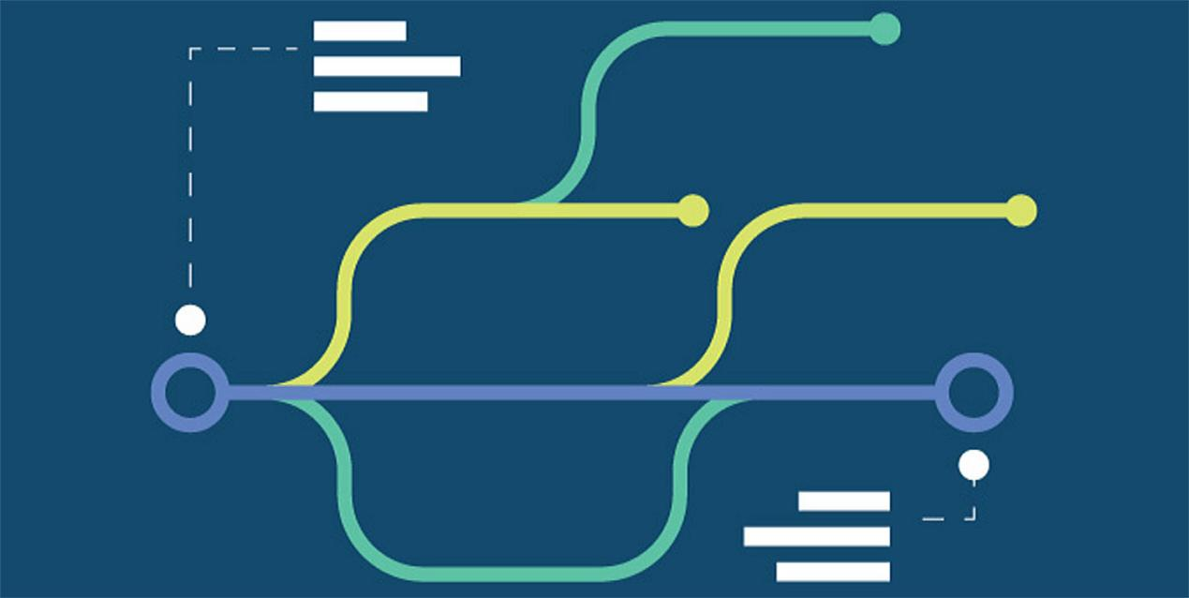

Using Git for version controlling was an essential part of our project, as it allowed us to manage and track changes to our code-base. By using Git, we were able to collaborate effectively, working on the same code-base and making changes without worrying about losing previous versions of our work. Git allowed us to revert changes easily and to keep track of who made specific changes, ensuring that our code-base was always in a stable and usable state. Additionally, Git allowed us to work on different parts of the code-base simultaneously, with each team member able to work on their own branch and merge their changes when they were complete. This process ensured that we had minimal conflicts and that our code-base was always up to date. Overall, the use of Git was a critical component of our project, and it helped us to work collaboratively and efficiently towards our shared goal.

**Learning new skills and knowledge**



Participating in the group project gave me the opportunity to learn new skills and gain knowledge in several areas. Specifically, I learned a lot about the MERN Stack technology, including how to set up a server using Node.js, create web applications using React, and how to use MongoDB for data storage. These skills have given me a deeper understanding of full-stack web development and the ability to apply these skills to future projects. Additionally, the use of Git for version control gave me a better understanding of how to collaborate effectively with a team on a code-base. The project also allowed me to improve my communication and collaboration skills, including learning how to work more effectively with others and how to give and receive feedback constructively. Overall, the experience has helped me to grow both personally and professionally, providing me with valuable skills and knowledge that will benefit me in future projects and career opportunities.

In conclusion, working on a group project that utilized the MERN Stack technology was a valuable experience that provided me with numerous opportunities for personal and professional growth. Through collaborating with my fellow group members and using Git for version control, I gained new skills and knowledge in full-stack web development and improved my communication and collaboration skills. The project's success was a result of our cohesive and collaborative team environment, where we leveraged each other's strengths to achieve our shared goal. Moving forward, I am excited to apply the skills and knowledge gained from this project to future projects and to continue working collaboratively with others to achieve our shared goals. Overall, this experience has taught me the importance of collaboration and how it can lead to better outcomes in group projects.